|  |  |
| --- | --- |
| TANGUB CITY GLOBAL COLLEGE  J. Luna St., Maloro, Tangub City, Misamis Occidental    **INSTITUTE OF COMPUTER STUDIES**  **1st Semester, Academic Year 2024-2025** | |
| Student ID No.: 214527 | Name: Joevie P. Duhaylungsod |
| Schedule: 12:00 – 1:00 (MW) | Date: 15/11/2024 Score: |

**WEBINAR SUMMARY REPORT**

**Webinar 2: 𝗔𝗜 𝗙𝘂𝗻𝗱𝗮𝗺𝗲𝗻𝘁𝗮𝗹𝘀 𝘄𝗶𝘁𝗵 𝗜𝗻𝘁𝗲𝗿𝗻𝗮𝘁𝗶𝗼𝗻𝗮𝗹 𝗕𝘂𝘀𝗶𝗻𝗲𝘀𝘀 𝗠𝗮𝗰𝗵𝗶𝗻𝗲𝘀 (𝗜𝗕𝗠) 𝗦𝗸𝗶𝗹𝗹𝘀𝗕𝘂𝗶𝗹𝗱**

**Date: 𝗔𝘂𝗴𝘂𝘀𝘁 𝟮𝟲-𝟯𝟬 𝟮𝟬𝟮𝟰**

**Executive Summary**

The "AI Fundamentals with IBM SkillsBuild" course introduces essential AI concepts, covering machine learning, natural language processing, and data science through practical, hands-on learning. Designed in partnership with IBM, it equips learners with skills to understand and apply AI in real-world contexts, preparing them for roles in AI-driven industries.

**Discussion**

To begin an overview of IBM’s "AI Fundamentals" course offers an accessible introduction to AI, covering essentials like machine learning and neural networks while focusing on real-world applications. It equips learners with practical skills and emphasizes ethical AI use, preparing them for the tech-driven business world.

**Concluding Remarks**

The session wrapped up with a call for participants to take a proactive approach in applying in conclusion, AI Fundamentals with IBM SkillsBuild has provided a valuable foundation in understanding the transformative potential of artificial intelligence. Through engaging lessons and practical insights, this program equips learners with essential AI knowledge and hands-on skills relevant to today’s evolving workforce. By bridging technology with real-world applications, it empowers us to navigate and shape the future with confidence and responsibility, ensuring that AI advancements serve both business innovation and broader societal needs.

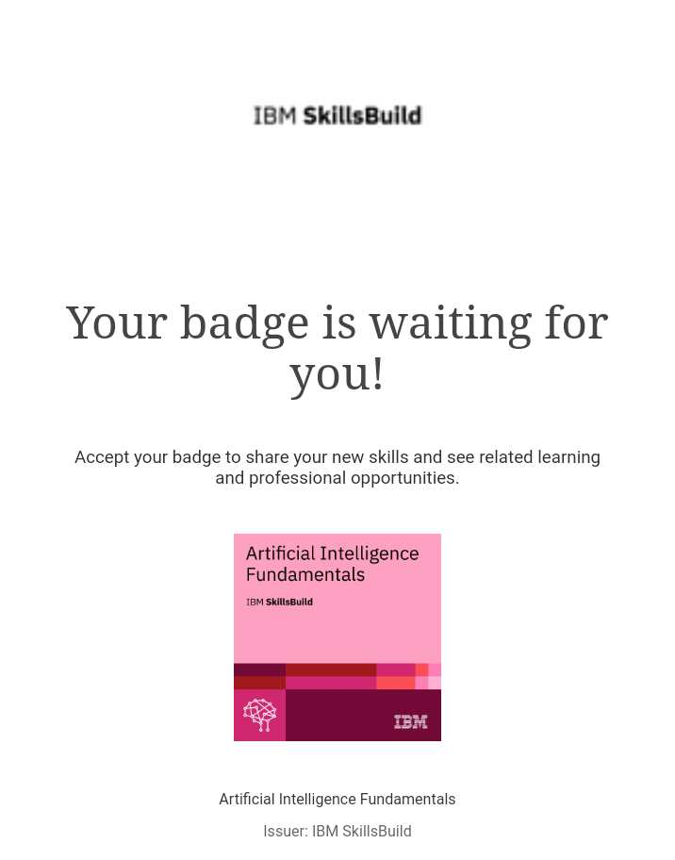**CERTIFICATION:**

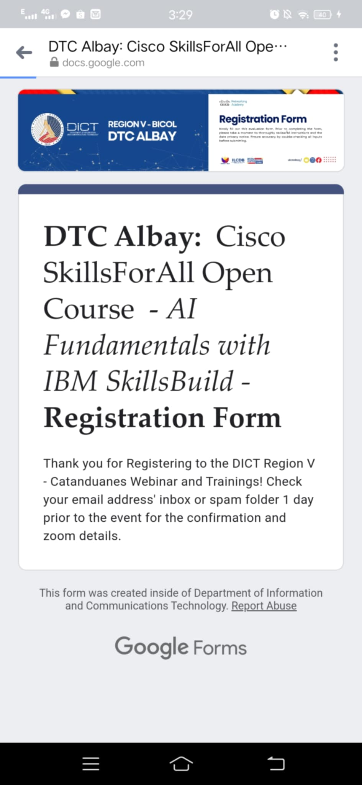**REGISTRATION:**

**ATTENDANCE AND EVALUATION:**